

***ASSIGNMENT NO. 03***

**FALL - 2022**

**DATE : 01/01/2023 SUBMISSION : 07/01/2023**

**Muhammad Muaz Shahzad 02-131202-081**

**Q. 1 (FINANCIAL STATEMENT)**

The following balances have been taken from the ledger of Raza & Co. on December 31, 2013.

|  |  |  |  |
| --- | --- | --- | --- |
| **S.NO.** | **ACCOUNTS TITLES** | **DEBIT** | **CREDIT** |
| 1. | Cash | 60,000 |  |
| 2. | Accounts Receivable | 40,000 |  |
| 3. | Merchandise Inventory (December 1, 2013) | 80,000 |  |
| 4. | Prepaid Insurance | 26,000 |  |
| 5. | Office Equipment | 50,000 |  |
| 6. | Purchases | 190,000 |  |
| 7. | Salaries Expense | 30,000 |  |
| 8. | Sales Return | 25,000 |  |
| 9. | Account Payable |  | 38,000 |
| 10. | Notes Payable |  | 32,000 |
| 11. | Unearned Rent |  | 32,000 |
| 12. | Sales |  | 220,000 |
| 13. | Accumulated Depreciation |  | 22,000 |
| 14. | Raza’s Capital |  | 157,000 |
| 15. |  | **501,000** | **501,000** |

Merchandise Inventory on December 31, 2013 was 25,000.

**Required:**

1. Income statement for the year ended December 31, 2013.
2. Balance sheet as on December 31, 2013

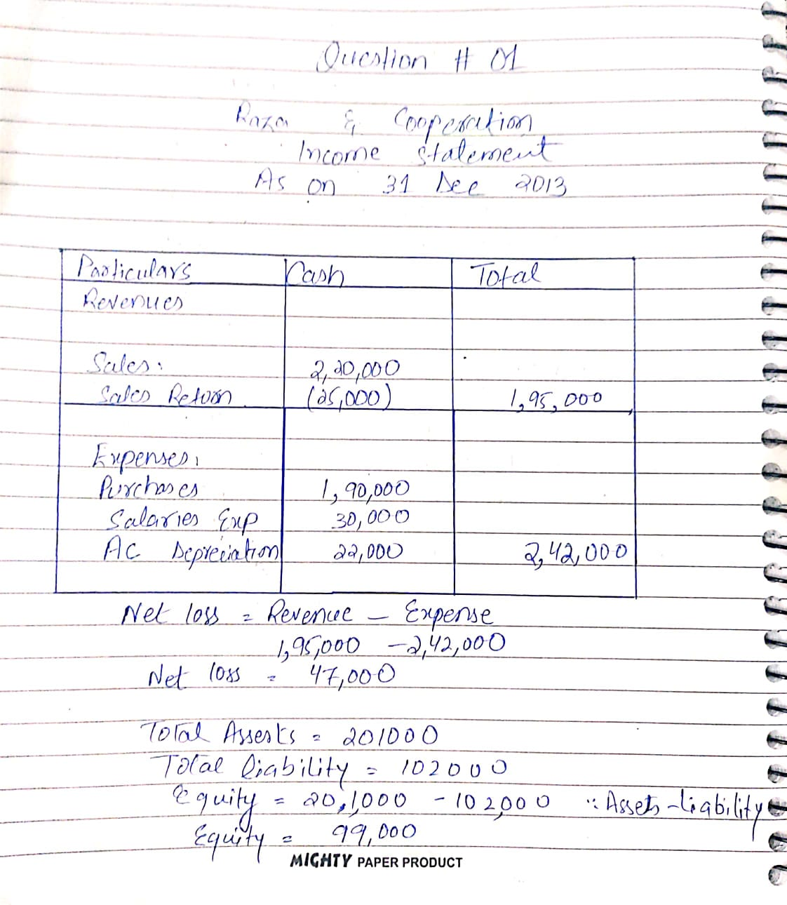

**Q. 2 (CASH BOOK)**

During the month of March, 2018 following transactions were completed by the Ali Traders.

**March**

1. Opening balance: Cash in hand Rs. 18,900

Cash at bank Rs. 25,400

2. Paid to Ameen by cheque Rs. 5,300

5. Sold goods for cash Rs. 17,900

8. Received cheque from Kamran and deposited in bank Rs. 19,700

11. Bought goods for cash Rs. 6,500

12. Sold goods for cash Rs. 22,900

15. Paid cheque for telephone bill Rs. 4,900

16. Withdrew from bank for personal use Rs. 2,550

17. Withdrew cash from bank Rs. 1000

18. Deposited cash in bank Rs. 5,800

22. Paid cheque for furniture paid Rs. 5,800

24. Received cheque from Zahid and deposited in bank Rs. 17,900

29. Paid salaries in cash Rs. 5,350

31. Paid cheque for rent Rs 5,890

31. Paid wages in cash Rs. 2,800

**Required:**

1. Record the above transaction in Cash Book.
2. Balance the Cash Book on March 31, 2018.
3. Bring down the balance on April 01, 2018.

